Learn to - Visualize Hands with aaBridge

Compiled by Roger Pfister http://RogerPf.com/aaBridge roger@RogerPf.com
The purpose of this exercise is to help you improve your ability to visualize what a hand will look like after a few tricks have been played. This will allow you to better choose between alternative lines of play.
The approach taken here is to learn one hand deeply in the expectation that such effort will spill over into seeing deeper into other hands when you are at the bridge table.
You are free to use any hand as a "learn deeply" hand. However, you may wish to follow along with the supplied example.
The Visualize Example hand is built into aaBridge (build number 2880 and later). You will find it on the opening page in the left hand column. It is just below the "---Examples---" separator.
To those with access, it can also be found in the BB_Students folder. See hand number 46.
To start - Show the Visualize Example hand in aaBridge and work through it in the normal way.
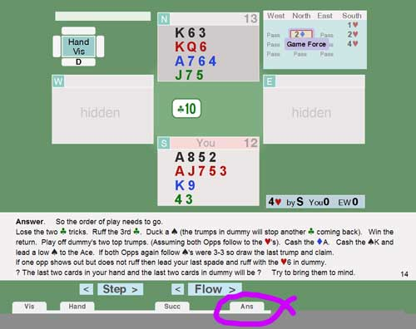
As usual a Success line of play in provided. Within this line of play on the Navbar is a 'bobble' named Ans, (see image). You can return to this point by clicking on that bobble.
- Try to Visualize (closing your eyes if it helps) how the North-South hands will look after the first couple of tricks.

- Play forward those two tricks -
Were you right ? If not try again.

- Repeat the above going forward more and more tricks.

The idea is to get you to practice trying to see what a hand will look like, if you play in a certain way.

Much later, try to bring the hand to mind, if you can't sleep, it's better than counting sheep.
A final thought, like many forms of memory training, repetition is the key. This exercise it is worth coming back to many times, with many different hands.

<end of document>

